DATE: | To implement CI/CD using Jenkins and to deploy a Music Streaming Web Application website
Aim:
To implement a Music Streaming Web Application using modern web technologies and to deploy it using a CI/CD pipeline with Jenkins and host it on a live server using Vercel.
Tools Required:
- Jenkins
- GitHub
- Git
- Vercel
- VS Code
Procedure:
Step 1: Create Simple Web Page (folder named moosic-app).
Step 2: Inside create files: index.html, glass-styles.css, music-engine.js, auth-engine.js, ui-engine.js.
Step 3: Write the code in the index.html, glass-styles.css, and the JavaScript engine files.
Step 4: Go to GitHub and create a repository named Moosic.
Step 5: After creating the repo run the below code in the command prompt terminal:
- git remote add origin https://github.com/your-username/Moosic.git
- git branch -M main
- git push -u origin main
Step 6: Install the Jenkins and go to Jenkins dashboard and click new item and name it Moosic-pipeline and select pipeline and click ok.
Step 7: Now configure the pipeline by scrolling down to the pipeline and paste the below code in the pipeline script:

pipeline {
agent any
stages {
stage('Clone') {
steps {
git branch: 'main', url: 'https://github.com/your-username/Moosic.git'
}
}
stage('Build') {
steps {
echo 'Building Moosic Audio Engine...'
}
}
stage('Deploy') {
steps {
bat 'if not exist C:\\moosic_deploy mkdir C:\\moosic_deploy'
bat 'xcopy * C:\\moosic_deploy /E /I /Y'
}
}
}
}
Step 8: After copying the code click save.
Step 9: To enable Auto CI/CD in Jenkins go to the triggers and enable Poll SCM.
Step 10: After ticking a box will appear, type * * * * * there.
Step 11: Now click save.
Step 12: Now the next step is to develop the Moosic Premium Audio website. The website will contain authentication overlay, music discovery section, real-time visualizer, and a liked songs playlist.
Step 13: Implement the logic to fetch music metadata via iTunes API and integrate the Web Audio API for real-time frequency analysis and playback controls.
Step 14: Create the JS engine files to handle persistent "Liked Songs" data and session-based user authentication using Local Storage.
Step 15: Install the vercel and click Add New then Project.
Step 16: Import the Moosic from the GitHub and click deploy.
Step 17: Now vercel will:
- Pull your code
- Deploy it
- Give a URL like: https://moosic-xxxx.vercel.app
Step 18: Now Push the code to the github, type the following in the command prompt terminal:
- git add .
- git commit -m "test1"
- git push
Step 19: Now the code will be pushed to the GitHub and Jenkins will auto run the job and build the job and deploy to the vercel.

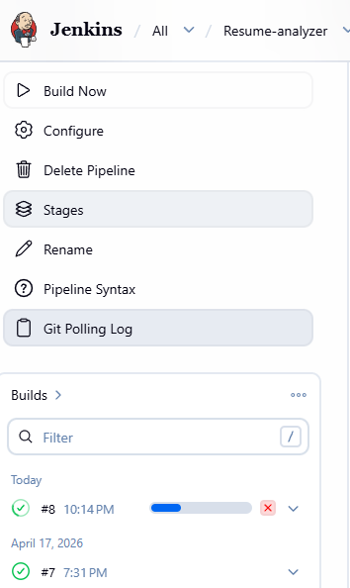

Step 20: Now after auto deployment the website will be live to the user:
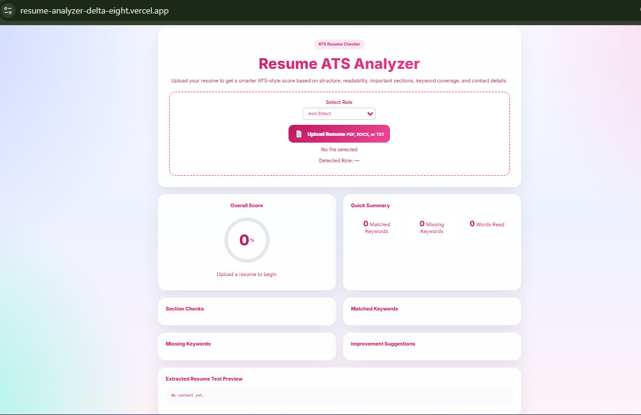
Step 21: Now make some changes in the code such as modifying the color theme of the website. In this project, the website theme is updated.
Step 22: Now again only push the code to the GitHub:
• git add .
• git commit -m "test2"
• git push
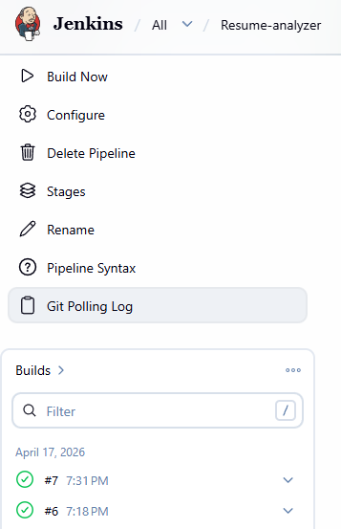

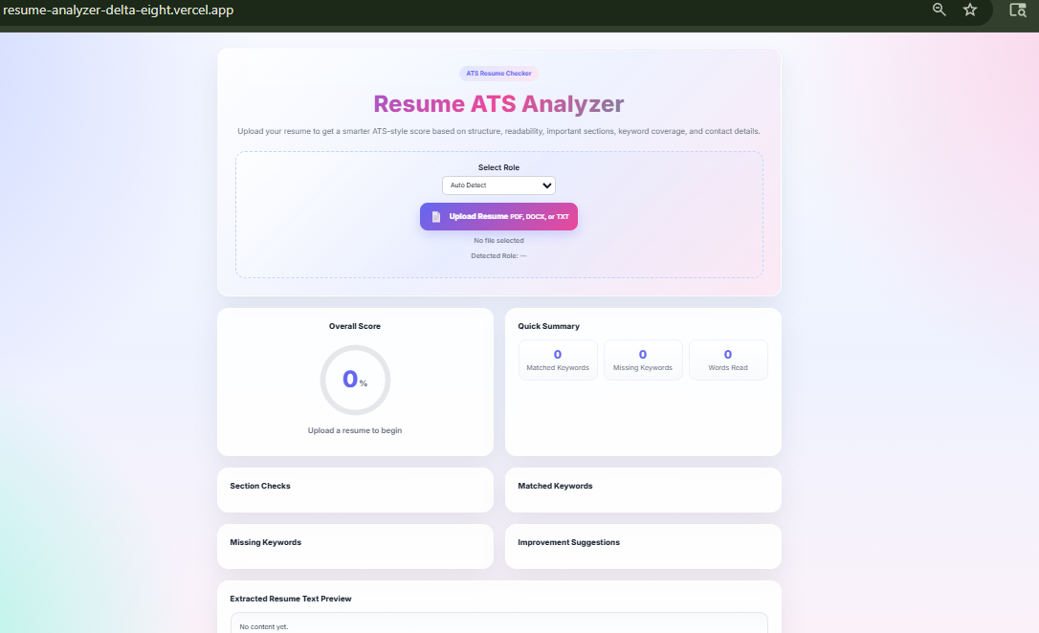
Step 23: Now refresh the URL to see the implementation of CI/CD using the jenkins

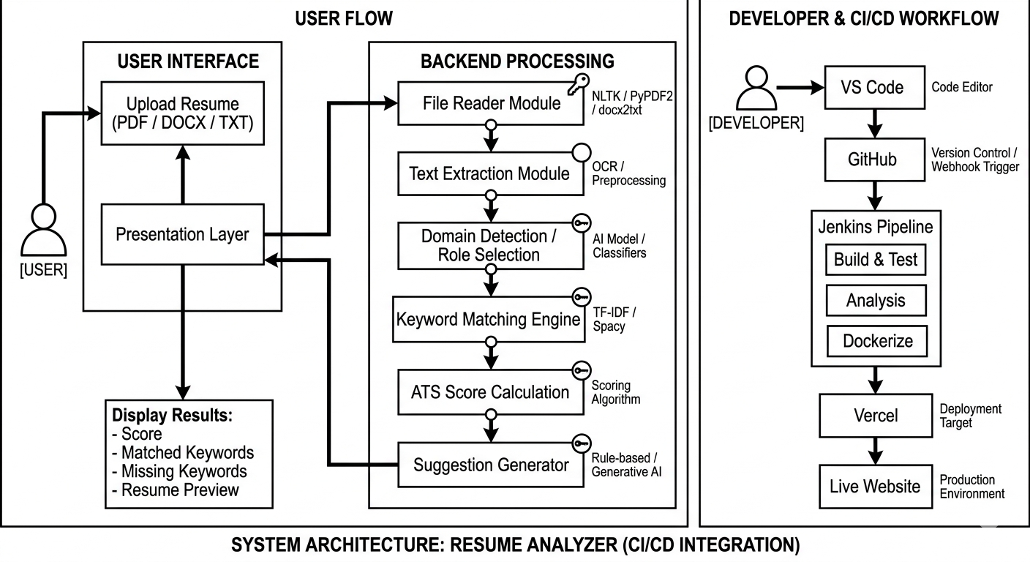
Architecture:

GitHub Repository Link:
https://github.com/Nithya-60/Resume-Analyzer.git

Deployment Link:
https://resume-analyzer-delta-eight.vercel.app/

Certificates in Infosys Springboard:
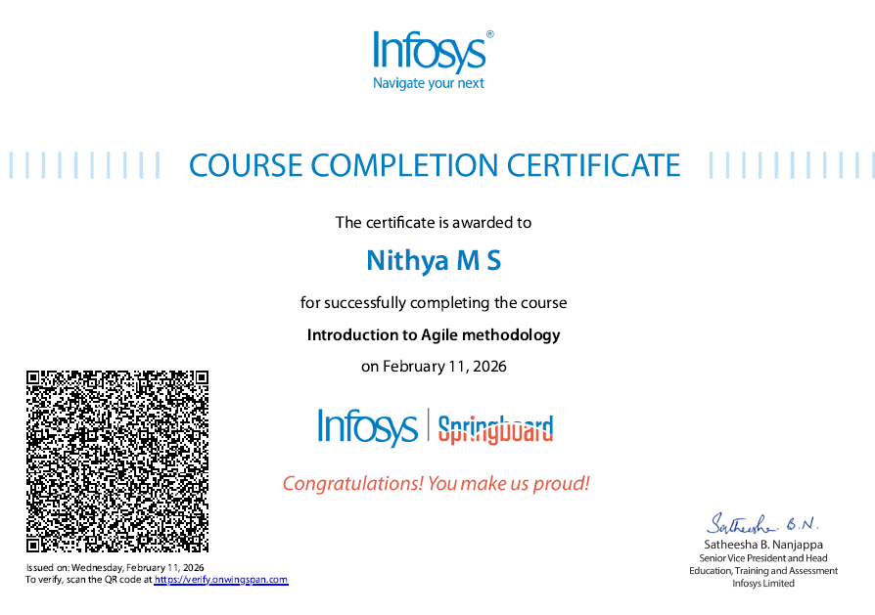
- Introduction to Agile methodology

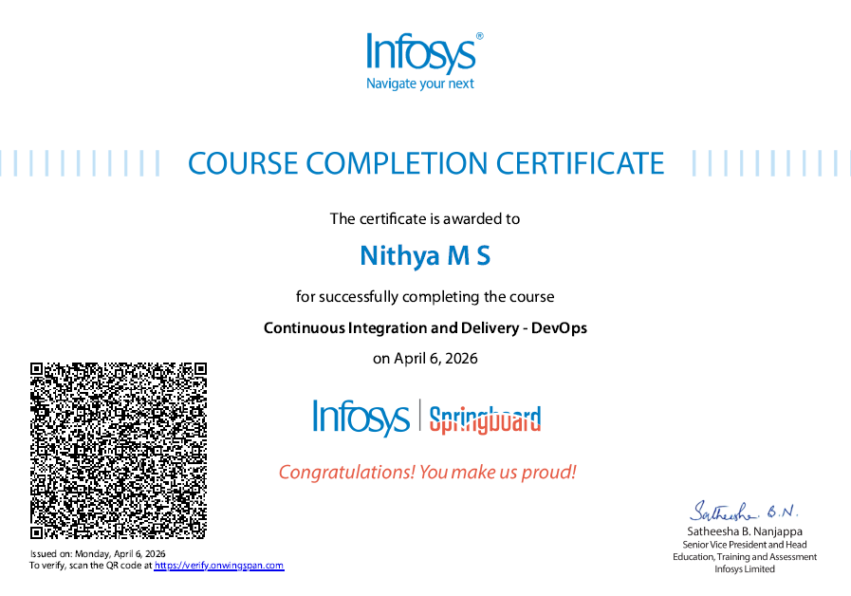
- Continuous Integration and Delivery - DevOps

Result:
Thus, the implementation of CI/CD using the Jenkins tool was successfully carried out and the Resume ATS Analyzer website was developed and deployed in Vercel for live usage. The system effectively analyzes resumes, calculates ATS scores, and displays keyword-based insights, demonstrating the integration of web development with DevOps practices.

